**9 - Creating a Data Source in ServiceNow**

Integration in ServiceNow begins with creating a Data Source based on its type (File, JDBC, OIDC, LDAP, REST, Custom). Common fields that appear during the creation of a Data Source include :-

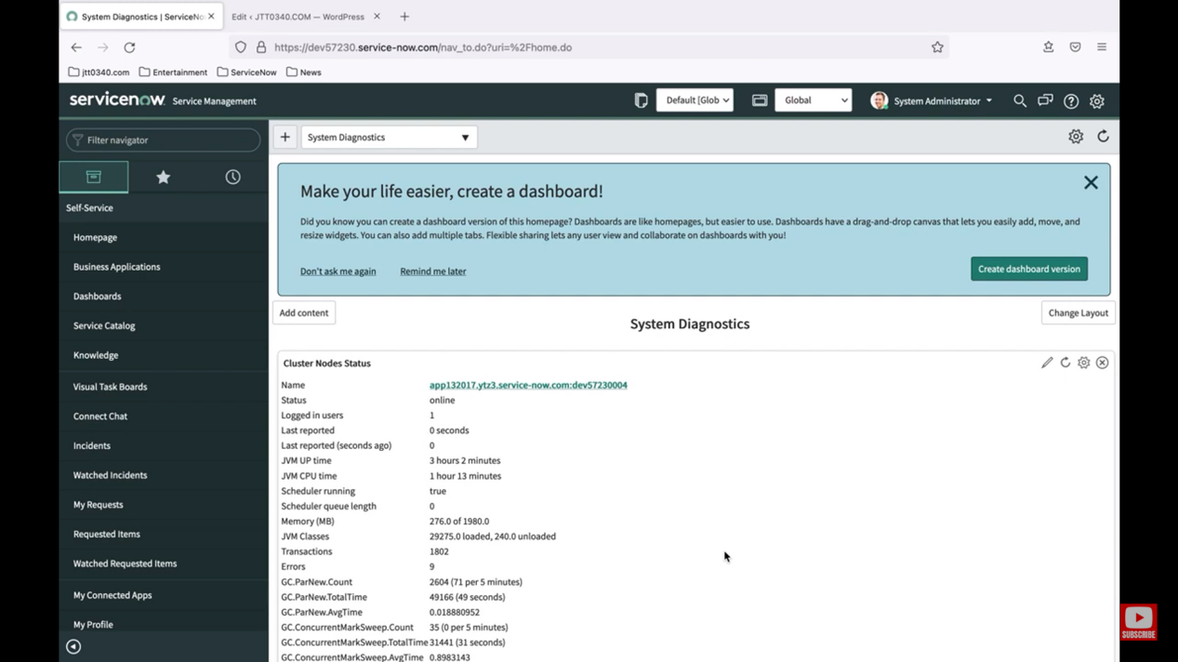  
   
 **Name - A unique name for this data source.  
 **Import set table label** - A label for the import set staging table to use.   
 **Import set table name** - ServiceNow uses the label you entered to create a unique table name to avoid conflicts with existing tables.   
 **Type** - The type of data that can be imported:5\\** From a remote File  
 From a JDBC database  
 Using LDAP  
 Using OIDC   
 Using REST to import data through the Integration Hub From a Data Stream action through the Integration Hub Using a Custom script  
 **Use Batch Import** - If selected, specifies that data loading should be batched when you click "Load data" or "Test load 20 records."   
 **Batch Size** - Specifies the size of the batches and appears only when "Use Batch Import" is selected.   
 **Application** - The application scope for this record.

**Collection and Importing into ServiceNow -** Importing allows us to configure, run, and schedule data imports through a single, simplified interface. It consolidates various data integration capabilities into one environment, eliminating the need to create and manage multiple forms throughout the platform. The step-by-step experience guides you through configuring data sources, target tables, and data mapping. Data imports can be scheduled or run on demand.

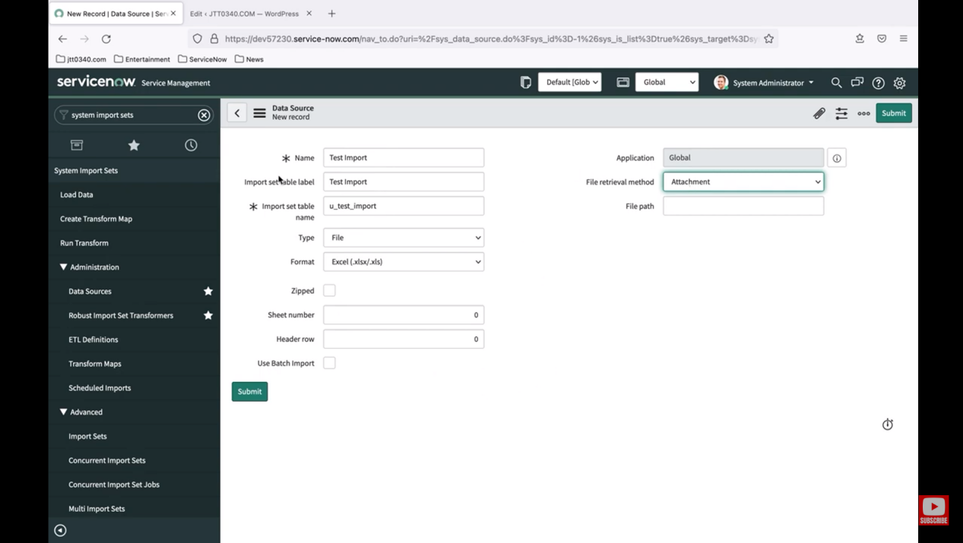

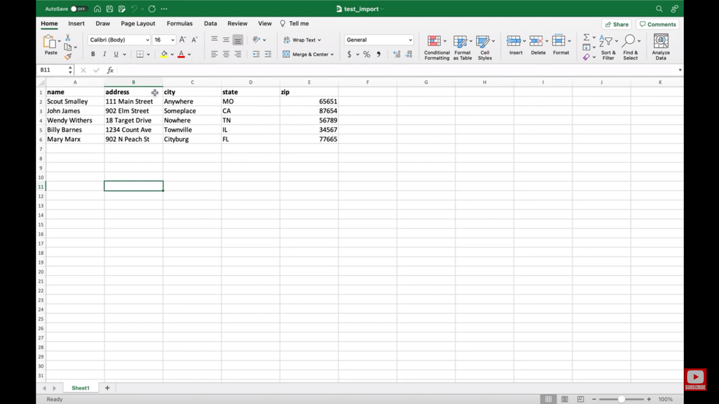

ANANYA CHOUDHARY